Spellings Topic words Spring 1
TEST: Monday 12th January 2025
Week 1 Spring 1
MAKE SURE YOU KNOW WHAT EACH WORD MEANS - USE A DICTIONARY
 | Word List |  |  |  |  | 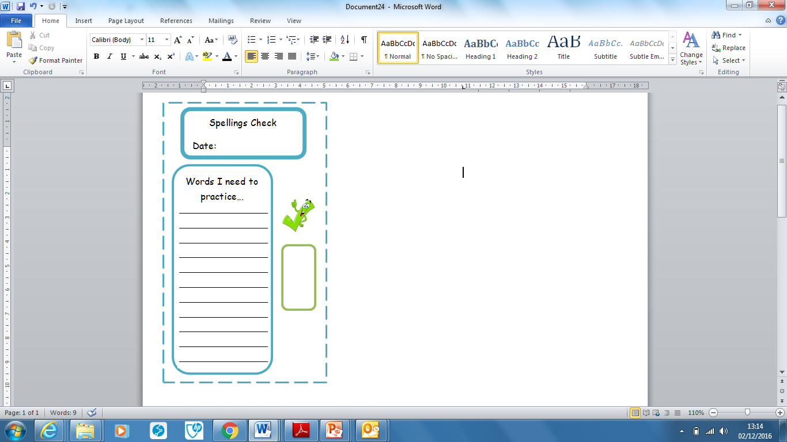
Spellings | Monday | Tuesday | Wednesday | Thursday | Friday
evaporation
filtering
identify
sieving
melting
irreversible
reversible
dissolving
mixing
evaporating

Ask for help if you are not sure what to do. Challenge on the back of this spelling sheet can you use each of your spellings in a sentence?

