This week’s sounds:
Words with ending in -ly
Words from Year 3 & 4 statutory word list
DUE: Friday 4th October
Week Beginning: 23rd September
MAKE SURE YOU KNOW WHAT EACH WORD MEANS - USE A DICTIONARY
 | Word List |  |  |  |  | 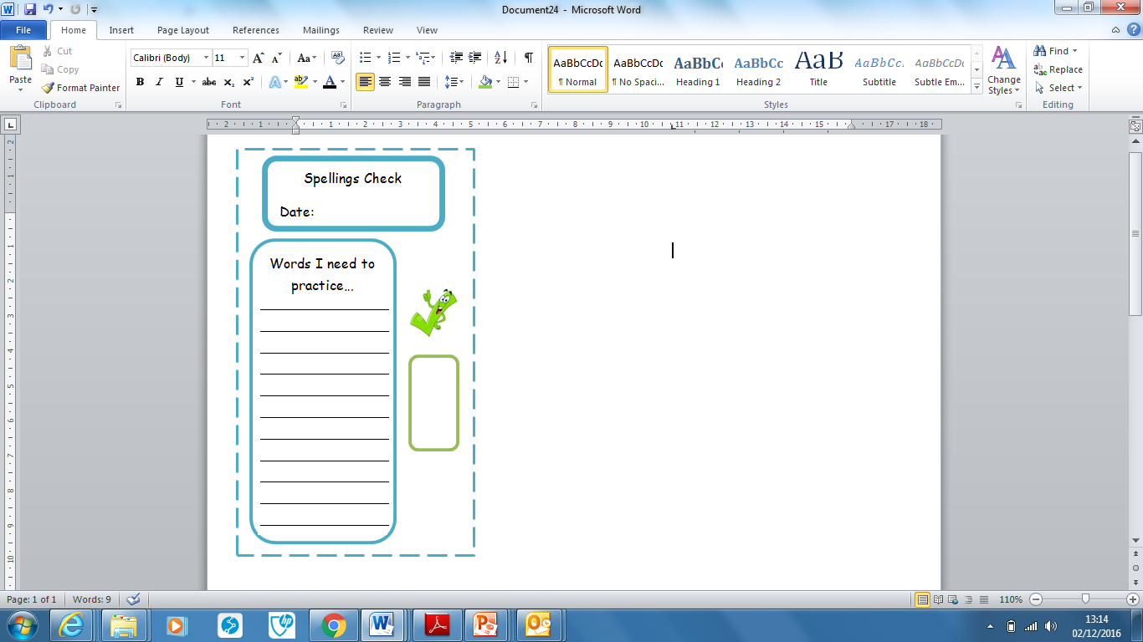
Spellings | Monday | Tuesday | Wednesday | Thursday | Friday
angrily
automatically
finally
happily
heavily
magically
sleepily
although
answer
appear

Ask for help if you are not sure what to do. Challenge on the back of this spelling sheet can you use each of your spellings in a sentence?

