Spellings word aware
TEST: Monday 24rd Feb 2025
Week 6 Spring 1
MAKE SURE YOU KNOW WHAT EACH WORD MEANS - USE A DICTIONARY
 | Word List |  |  |  |  | 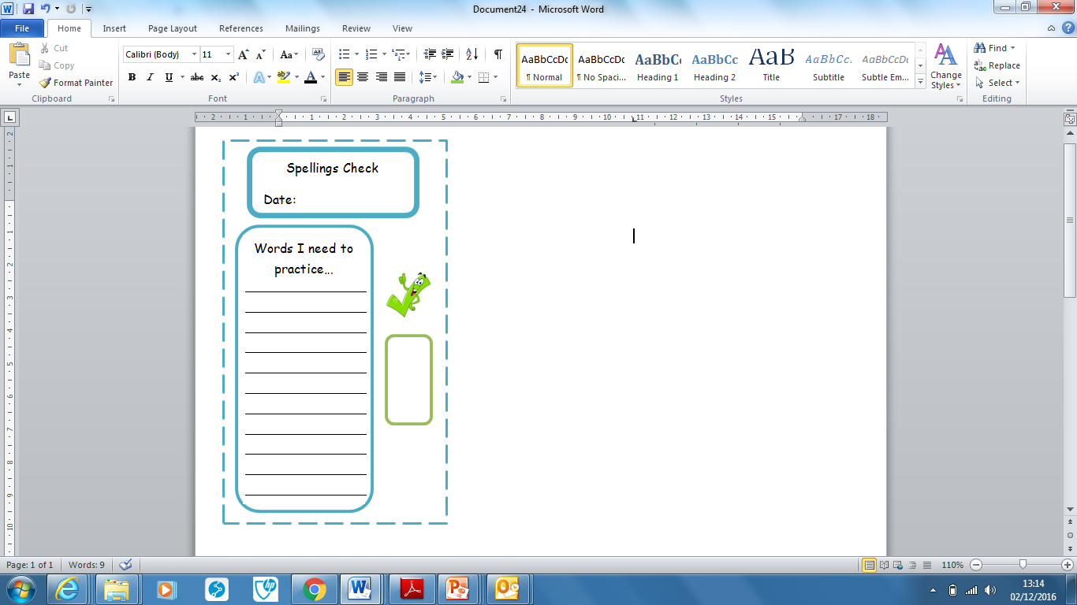
Spellings | Monday | Tuesday | Wednesday | Thursday | Friday
perilous

slumber

incognito

mayhem

rouse

ominous

Ask for help if you are not sure what to do. Challenge on the back of this spelling sheet can you use each of your spellings in a sentence?

