This week’s sounds:
Words with prefix inter-
Words from Year 3 & 4 statutory word list
DUE: Friday 11th October
Week Beginning: 30th September
MAKE SURE YOU KNOW WHAT EACH WORD MEANS - USE A DICTIONARY
 | Word List |  |  |  |  | 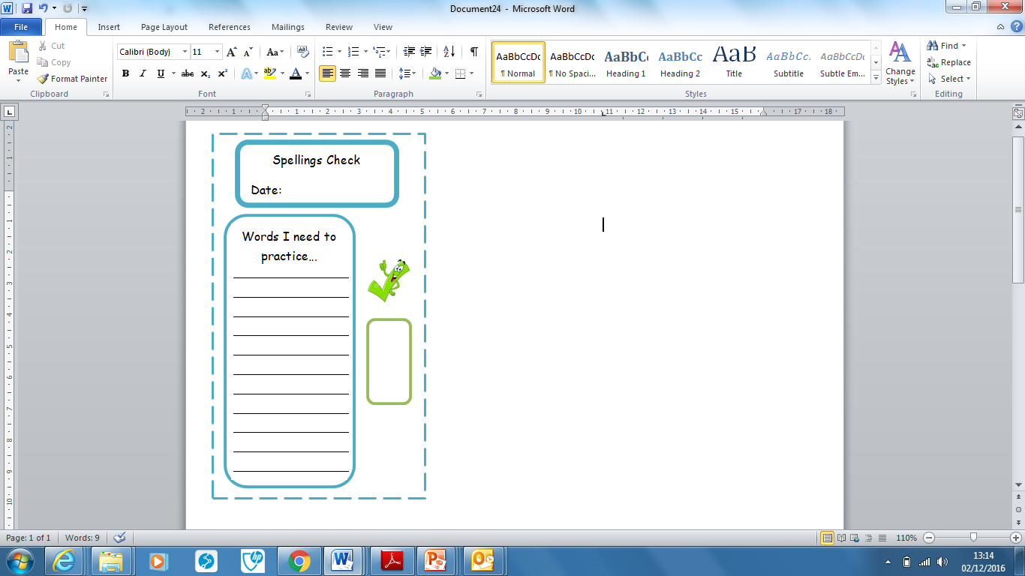
Spellings | Monday | Tuesday | Wednesday | Thursday | Friday
interact
interactive
intermediate
international
internet
arrive
believe
bicycle
breath
breathe

Ask for help if you are not sure what to do. Challenge on the back of this spelling sheet can you use each of your spellings in a sentence?

