Spellings Group 1
DUE: 24th Sept 2024
Week Ending: 20th September Friday
MAKE SURE YOU KNOW WHAT EACH WORD MEANS - USE A DICTION
 | Word List |  |  |  |  | 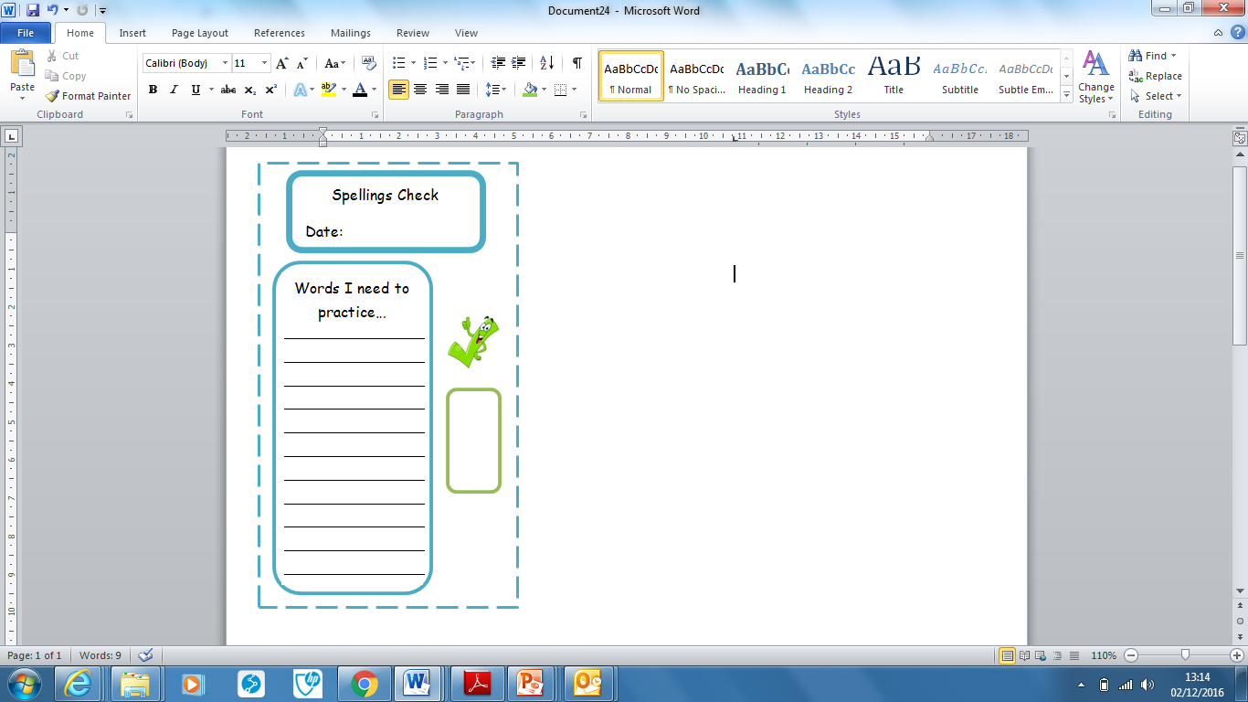
Spellings | Monday | Tuesday | Wednesday | Thursday | Friday
straight
available
paragraph
separate
remember
suppose
reported
February
natural
quarter

Ask for help if you are not sure what to do. Challenge on the back of this spelling sheet can you use each of your spellings in a sentence?

