Spellings Words Week 1

Liberty James D Andrew Curtis

DUE: 10th June
Week Ending: Friday 7th June
MAKE SURE YOU KNOW WHAT EACH WORD MEANS - USE A DICTIONARY
 | Word List |  |  |  |  | 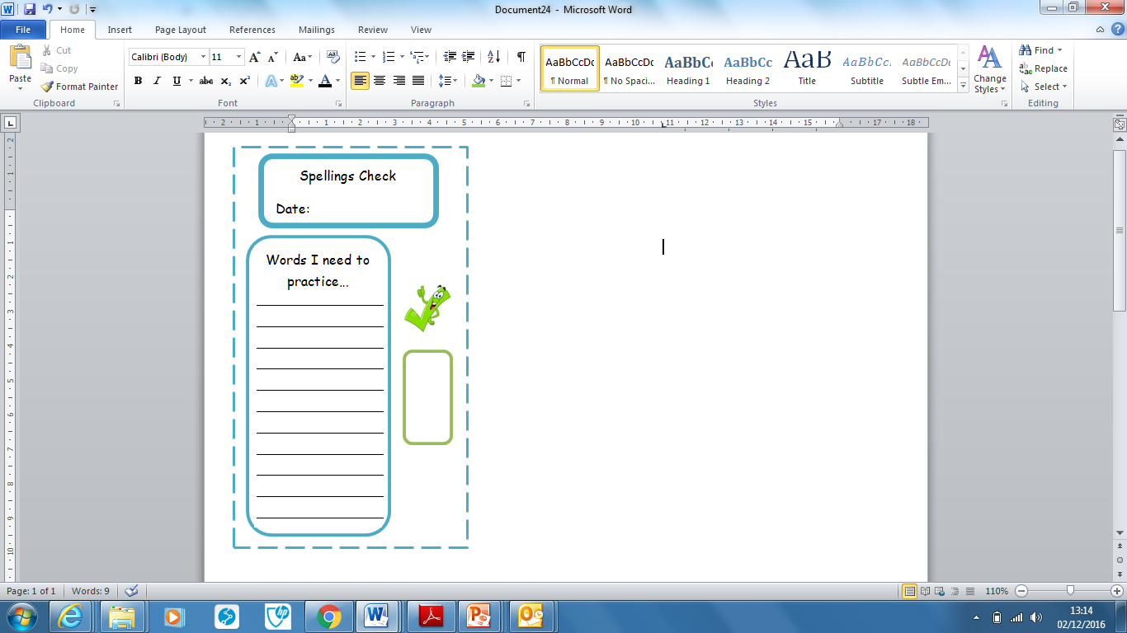
Spellings | Monday | Tuesday | Wednesday | Thursday | Friday
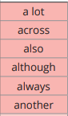

Ask for help if you are not sure what to do. Challenge on the back of this spelling sheet can you use each of your spellings in a sentence?

