Spellings Maths Vocabulary
DUE: 14th October
Week Ending :11th October Friday
MAKE SURE YOU KNOW WHAT EACH WORD MEANS - USE A DICTIONARY
 | Word List |  |  |  |  | 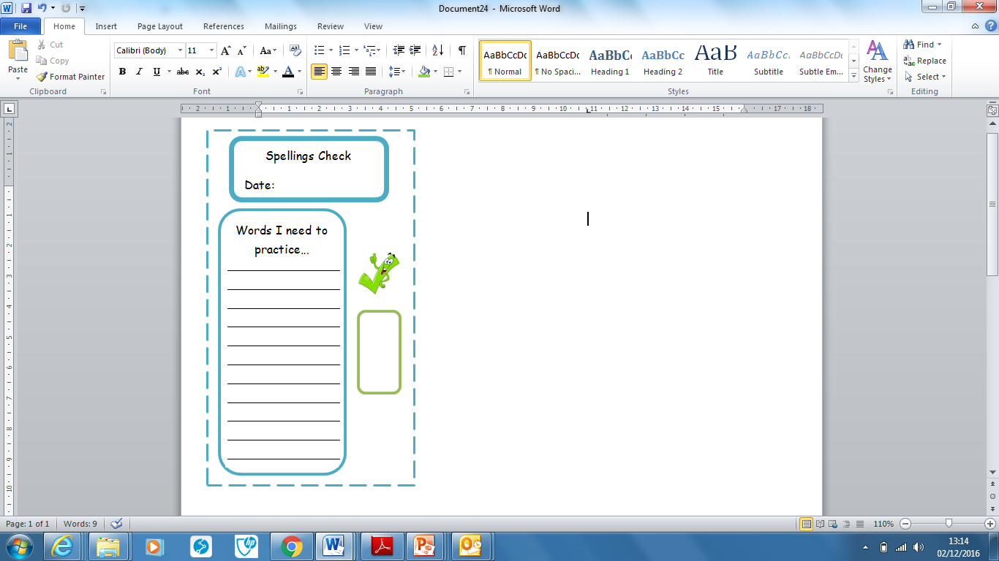
Spellings | Monday | Tuesday | Wednesday | Thursday | Friday
difference
multiple
symmetry
fraction
litres
simplify
factor
duration
mode
perpendicular

Ask for help if you are not sure what to do. Challenge on the back of this spelling sheet can you use each of your spellings in a sentence?

