Spellings Space and maths words
TEST: 2nd December
Week Ending: 29th November Friday
MAKE SURE YOU KNOW WHAT EACH WORD MEANS - USE A DICTIONARY
 | Word List |  |  |  |  | 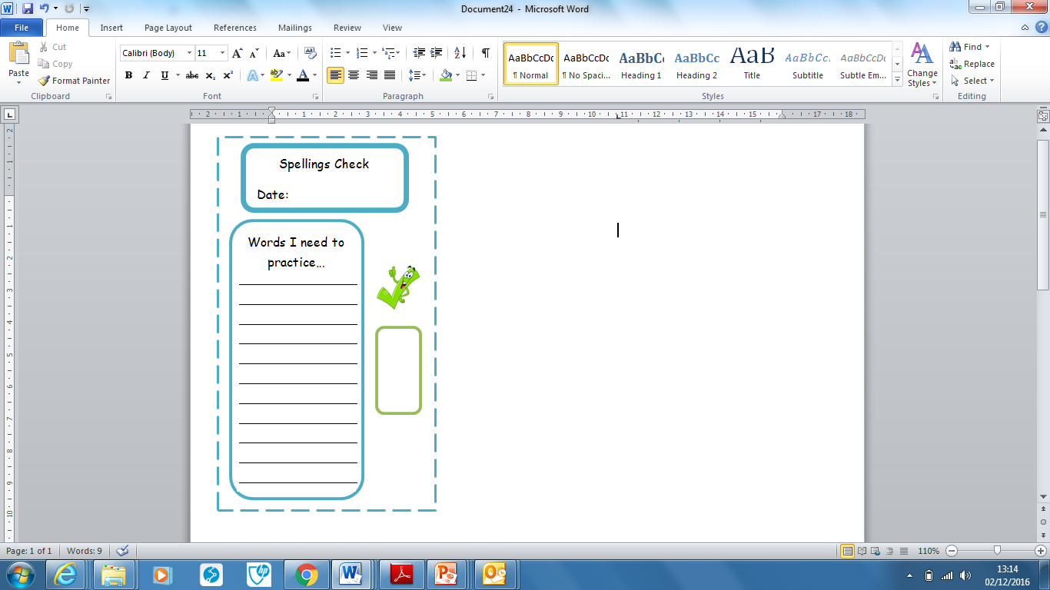
Spellings | Monday | Tuesday | Wednesday | Thursday | Friday
sphere
orbit
diameter
celestial
rotate
axis
heliocentric
geocentric
spherical
gravitational

Ask for help if you are not sure what to do. Challenge on the back of this spelling sheet can you use each of your spellings in a sentence?

