This week’s sounds:
Mix of common exception words and prefixes –un –mis -dis
DUE: Friday 13th September
Week Beginning: 2nd September
MAKE SURE YOU KNOW WHAT EACH WORD MEANS - USE A DICTIONARY
 | Word List |  |  |  |  | 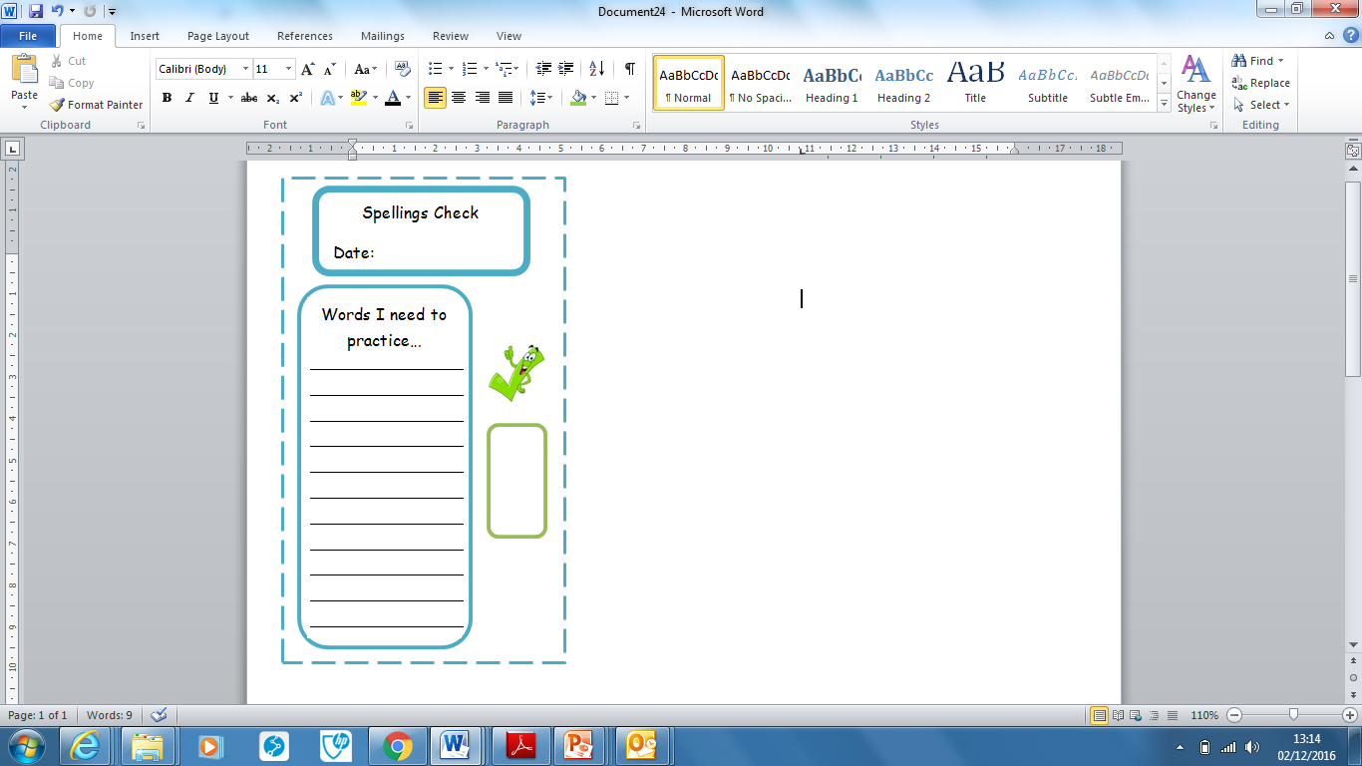
Spellings | Monday | Tuesday | Wednesday | Thursday | Friday
after
again
any
bath
beautiful
because
misplace
disagree
unfair
unkind
Ask for help if you are not sure what to do. Challenge on the back of this spelling sheet can you use each of your spellings in a sentence?

