Spellings -ance words
TEST: Monday 27th January 2025
Week 3 Spring 1
MAKE SURE YOU KNOW WHAT EACH WORD MEANS - USE A DICTIONARY
 | Word List |  |  |  |  | 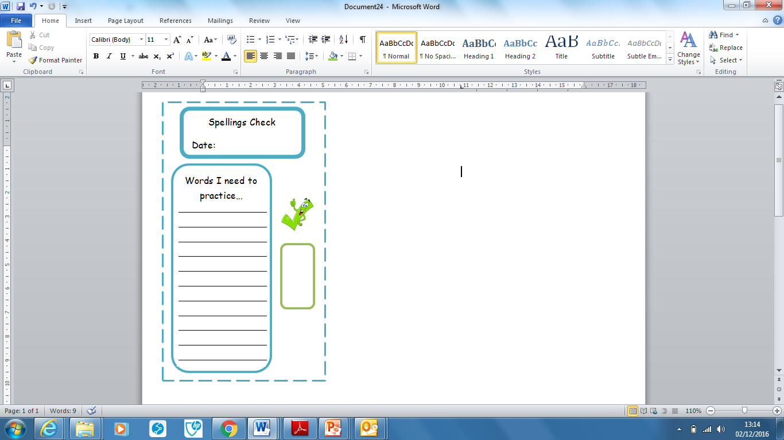
Spellings | Monday | Tuesday | Wednesday | Thursday | Friday
defiance
tolerance
distance
observance
elegance
reliance
assistance
instance
relevance
substance

Ask for help if you are not sure what to do. Challenge on the back of this spelling sheet can you use each of your spellings in a sentence?

