Spellings group 2 Words with the long vowel sound /i/ spelt with y
TEST: 18 th November
Week Ending: 15th November Friday
MAKE SURE YOU KNOW WHAT EACH WORD MEANS - USE A DICTIONARY
 | Word List |  |  |  |  | 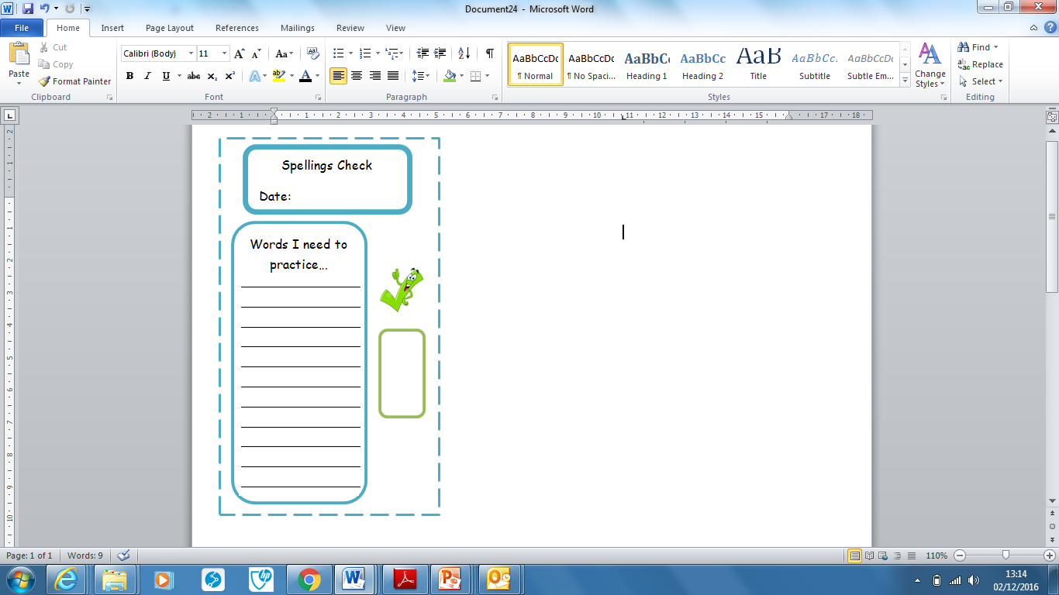
Spellings | Monday | Tuesday | Wednesday | Thursday | Friday
occupy
supply
identify
Multiply
rhyme
cycle
python
hygiene
hyphen
Apply

Ask for help if you are not sure what to do. Challenge on the back of this spelling sheet can you use each of your spellings in a sentence?

