This week’s sounds:
Mix of common exception words and words ending in -ly
DUE: Friday 4th October
Week Beginning: 23rd September
MAKE SURE YOU KNOW WHAT EACH WORD MEANS - USE A DICTIONARY
 | Word List |  |  |  |  | 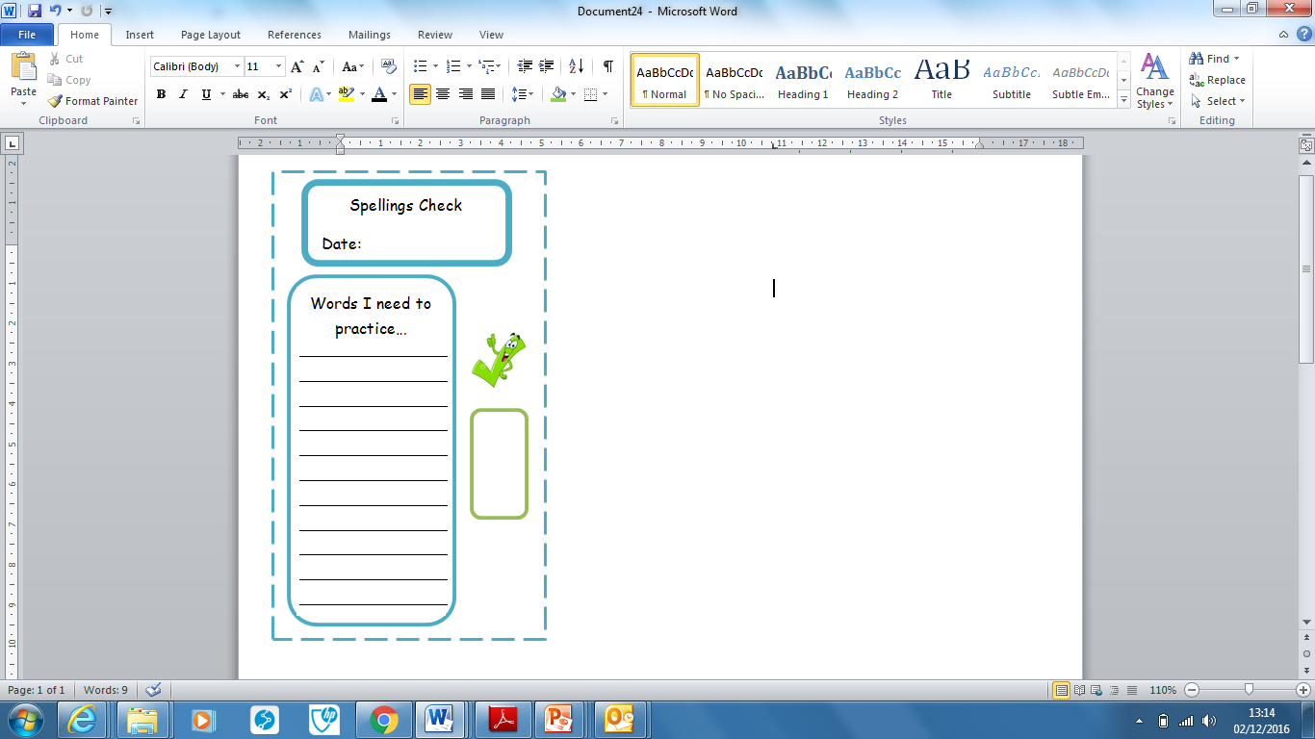
Spellings | Monday | Tuesday | Wednesday | Thursday | Friday
father
great
hour
improve
money
happily
angrily
sadly
slowly
nicely
Ask for help if you are not sure what to do. Challenge on the back of this spelling sheet can you use each of your spellings in a sentence?

