This week’s sounds:
Words with auto prefix
Words from Year 3 & 4 statutory word list
DUE: Friday 27th September
Week Beginning: 16th September
MAKE SURE YOU KNOW WHAT EACH WORD MEANS - USE A DICTIONARY
 | Word List |  |  |  |  | 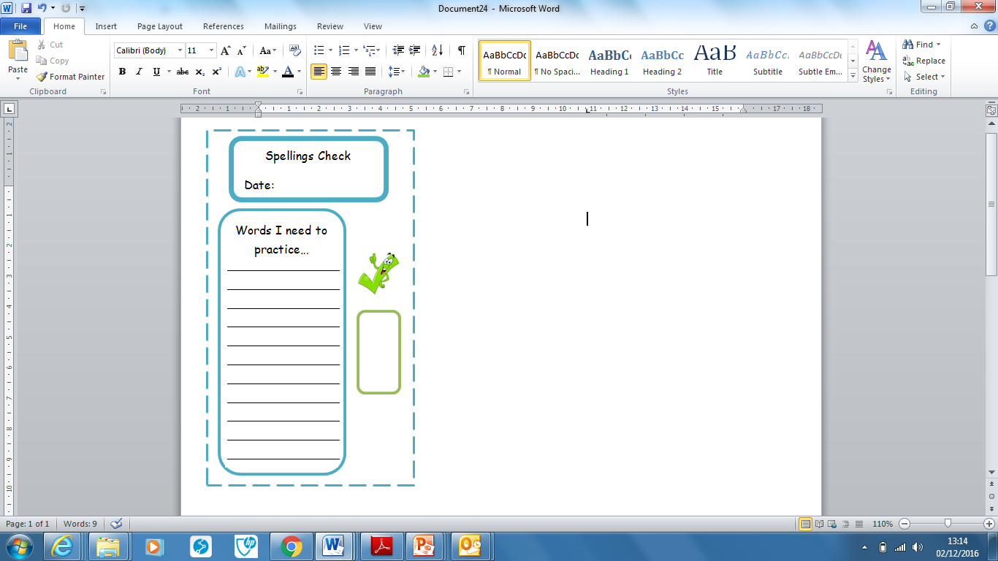
Spellings | Monday | Tuesday | Wednesday | Thursday | Friday
autobiography
automatic
autograph
automobile
autopilot
accident
accidentally
actual
actually
address

Ask for help if you are not sure what to do. Challenge on the back of this spelling sheet can you use each of your spellings in a sentence?

