Statutory spellings Group 1
Test: Tuesday 17th September
Week Ending: Friday 13th September
MAKE SURE YOU KNOW WHAT EACH WORD MEANS - USE A DICTIONARY
 | Word List |  |  |  |  | 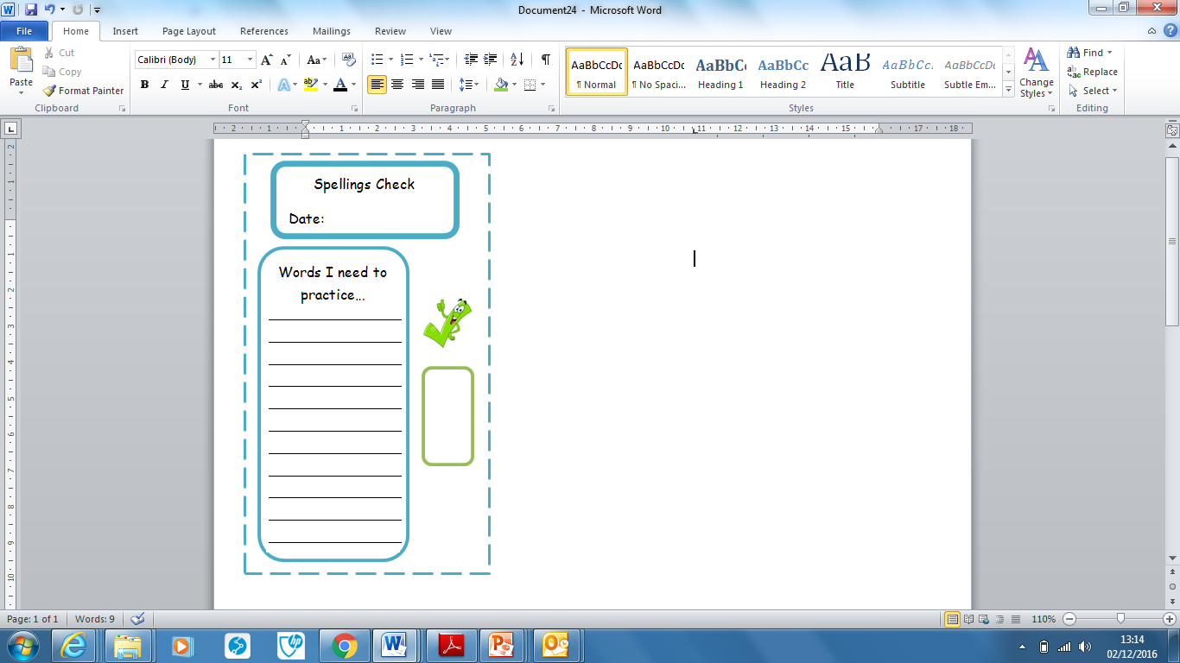
Spellings | Monday | Tuesday | Wednesday | Thursday | Friday
learn
fruit
weight
consider
early
occasion
occasionally
special
therefore
extreme

Ask for help if you are not sure what to do. Challenge on the back of this spelling sheet can you use each of your spellings in a sentence?

