This week’s sounds: Words ending in -ous
Words from Year 3 & 4 statutory word list
DUE: Friday 25th October
Week Beginning: 14th October
MAKE SURE YOU KNOW WHAT EACH WORD MEANS - USE A DICTIONARY
 | Word List |  |  |  |  | 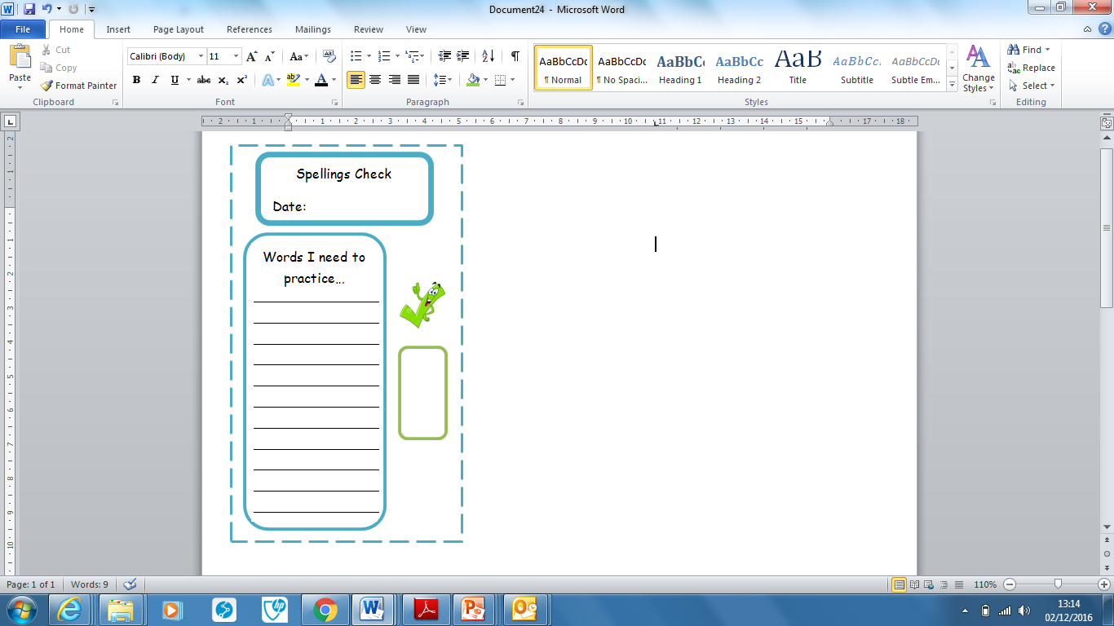
Spellings | Monday | Tuesday | Wednesday | Thursday | Friday
anxious
dangerous
enormous
obvious
adventurous
centre
century
certain
circle
complete

Ask for help if you are not sure what to do. Challenge on the back of this spelling sheet can you use each of your spellings in a sentence?

