This week’s sounds:
Words ending in –zhuh spelt –sure
Words ending in –ture (revision)
DUE: Friday 20th September
Week Beginning: 9th September
MAKE SURE YOU KNOW WHAT EACH WORD MEANS - USE A DICTIONARY
 | Word List |  |  |  |  | 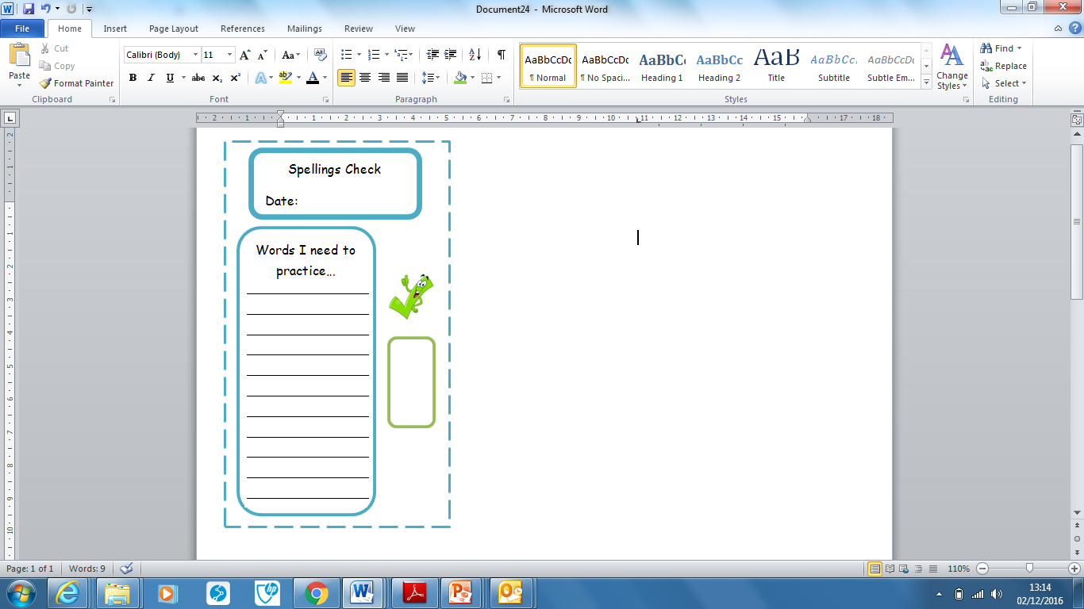
Spellings | Monday | Tuesday | Wednesday | Thursday | Friday
enclosure
leisure
measure
treasure
pleasure
adventure
creature
mixture
picture
capture
Ask for help if you are not sure what to do. Challenge on the back of this spelling sheet can you use each of your spellings in a sentence?

