This week’s sounds:
Statutory spellings Group 2
DUE: Tuesday 17th September
Week Ending: 13th September
MAKE SURE YOU KNOW WHAT EACH WORD MEANS - USE A DICTIONARY
 | Word List |  |  |  |  | 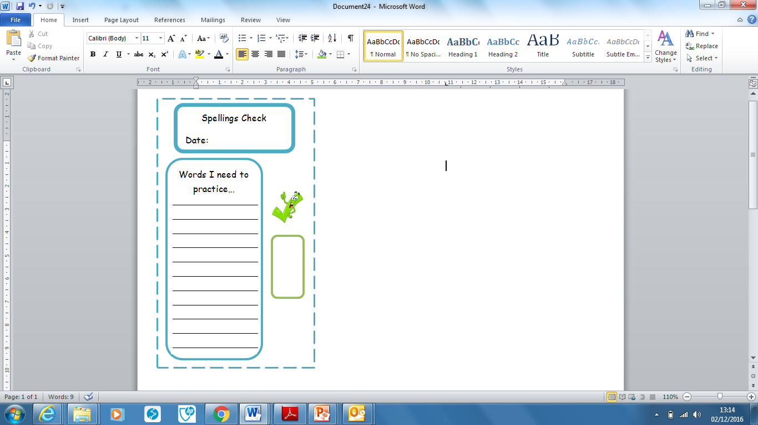
Spellings | Monday | Tuesday | Wednesday | Thursday | Friday
accommodate
accompany
according
appreciate
attached
metaphor
sufficient
communicate
community
orbit

Ask for help if you are not sure what to do. Challenge on the back of this spelling sheet can you use each of your spellings in a sentence?

