**Invaders – Sticky Knowledge**

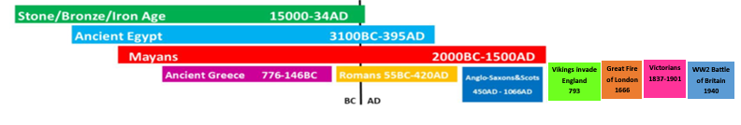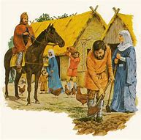 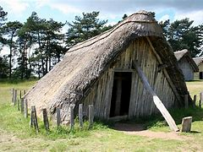 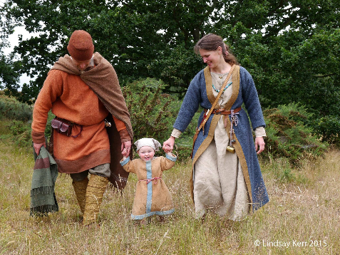

**Key Vocabulary:**

|  |  |  |  |
| --- | --- | --- | --- |
| Thane | Churl | Wergild | Legacy |
| Witan | pagan | Danegeld | Angles |

**Key Facts:**

* The Vikings came from all around Scandinavia (where Norway, Sweden and Denmark are today). The Vikings first attacked Britain in 787 AD, but didn’t start to invade and settle in the British Isles until 793. They lived here until around 1050.
* They spoke Norse, which had an alphabet made up of characters called runes.
* The Vikings left their homeland because they were looking for better places to farm than the kind of terrain that Scandinavia had.
* In 878, King Alfred the Great defeated the Vikings in battle and had them sign a treaty saying they had to keep to their own land in England – this section of land was called Danelaw.
* Viking warriors believed that when they died in battle, they went to Valhalla – this is where the king of the gods lived, named Odin.