Spellings group 2 words with short vowel sound /i/ spelt with a y
TEST: 12 th November
Week Ending: 8th November Friday
MAKE SURE YOU KNOW WHAT EACH WORD MEANS - USE A DICTIONARY
 | Word List |  |  |  |  | 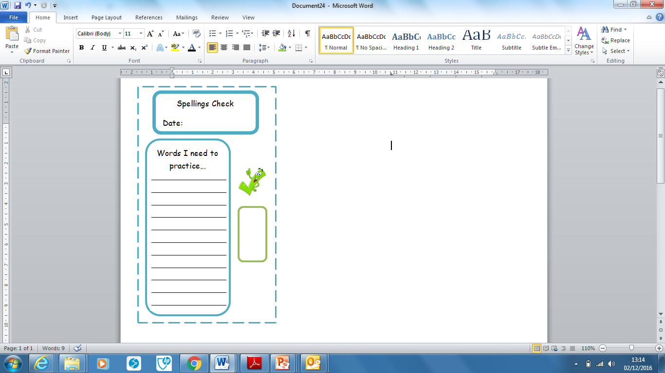
Spellings | Monday | Tuesday | Wednesday | Thursday | Friday
symbol
mystery
lyrics
oxygen
symptom
physical
system
crystal
typical
rhythm

Ask for help if you are not sure what to do. Challenge on the back of this spelling sheet can you use each of your spellings in a sentence?

