This week’s sounds:
Mix of common exception words and words with prefix auto-
DUE: Friday 27th September
Week Beginning: 16th September
MAKE SURE YOU KNOW WHAT EACH WORD MEANS - USE A DICTIONARY
 | Word List |  |  |  |  | 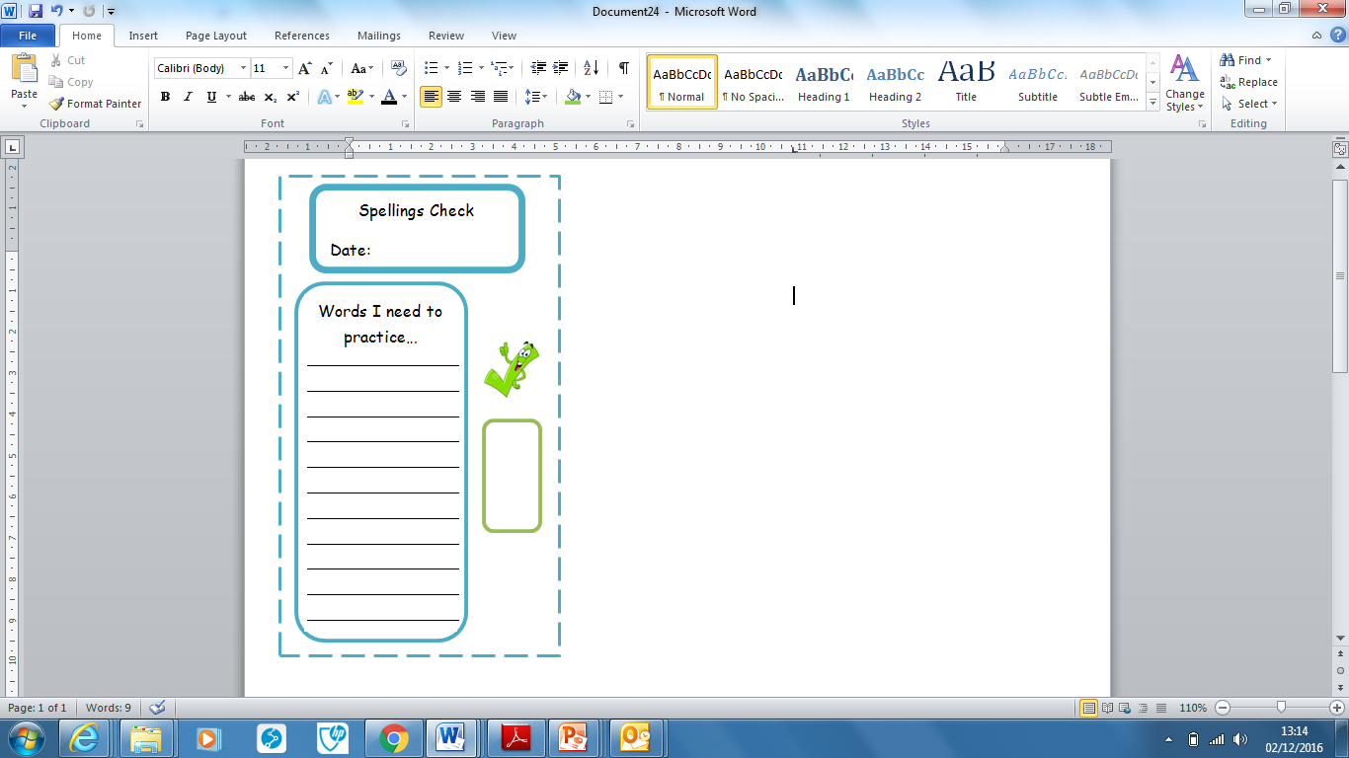
Spellings | Monday | Tuesday | Wednesday | Thursday | Friday
class
climb
clothes
could
everybody
floor
grass
automatic
autopilot
autocue
Ask for help if you are not sure what to do. Challenge on the back of this spelling sheet can you use each of your spellings in a sentence?

