Spellings group 1 adding the prefix im
TEST: 18 th November
Week Ending: 15th November Friday
MAKE SURE YOU KNOW WHAT EACH WORD MEANS - USE A DICTIONARY
 | Word List |  |  |  |  | 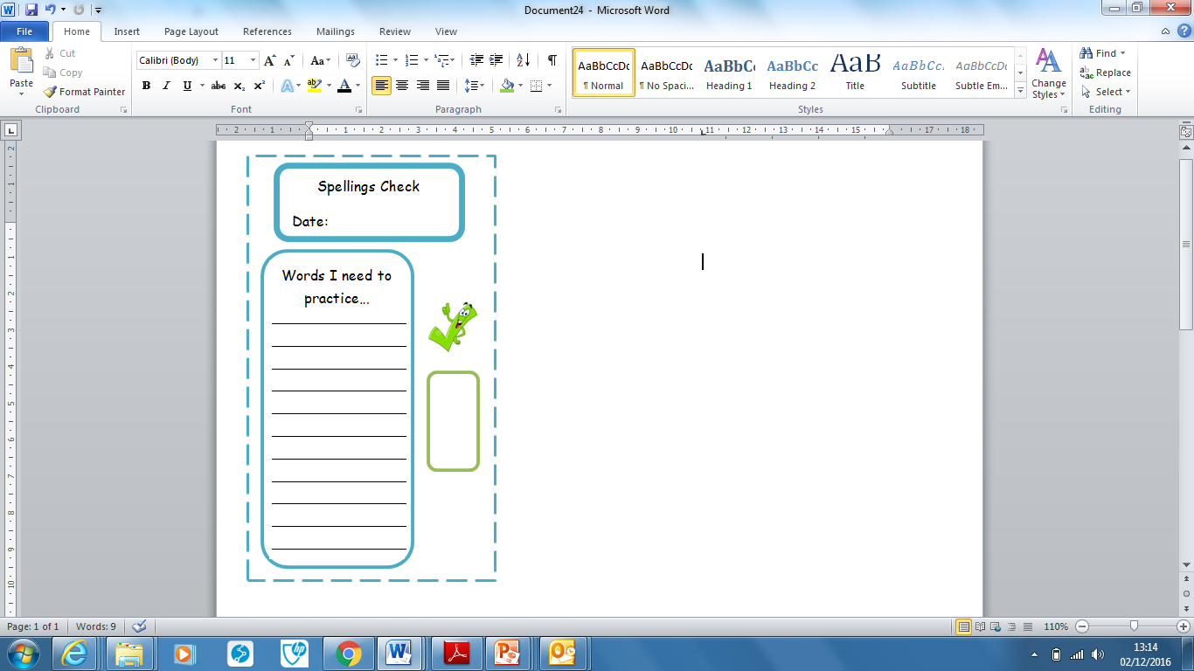
Spellings | Monday | Tuesday | Wednesday | Thursday | Friday
immature
impossible
impolite
important
immovable
immeasurable
immortal
impatient
improper
imperfect

Ask for help if you are not sure what to do. Challenge on the back of this spelling sheet can you use each of your spellings in a sentence?

