Spellings Common exception words
Test: 30th Sept 2024
Week Ending: 27th Sept Friday
MAKE SURE YOU KNOW WHAT EACH WORD MEANS - USE A DICTIONARY
 | Word List |  |  |  |  | 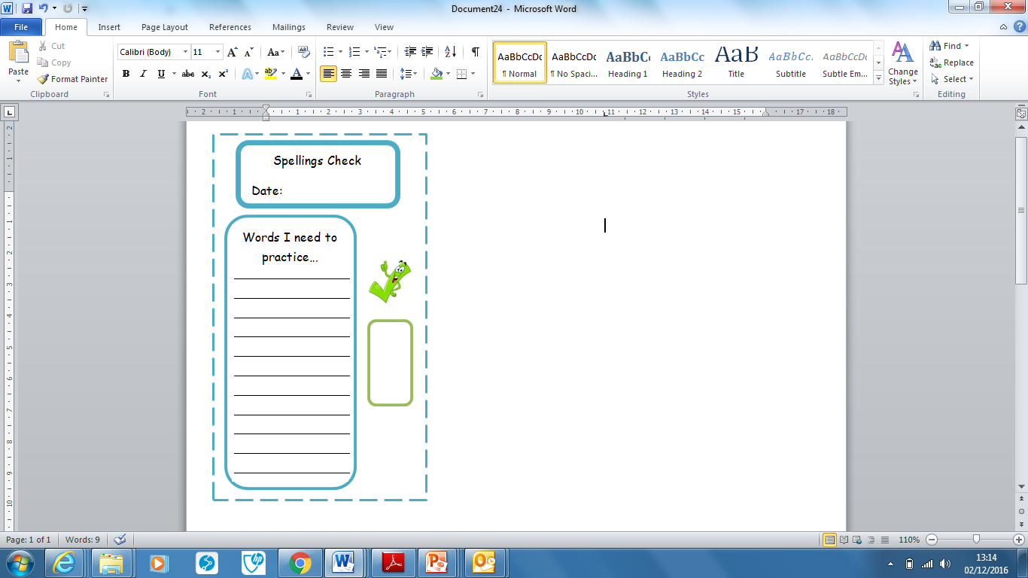
Spellings | Monday | Tuesday | Wednesday | Thursday | Friday
twelfth
they’re
thorough
would
stomach
soldier
sincerely
shoulder
secretary
source

Ask for help if you are not sure what to do. Challenge on the back of this spelling sheet can you use each of your spellings in a sentence?

