Spellings Group 1 commonly misspelt
Test 30th Sept 2024
Week Ending: 27th September Friday
MAKE SURE YOU KNOW WHAT EACH WORD MEANS - USE A DICTION
 | Word List |  |  |  |  | 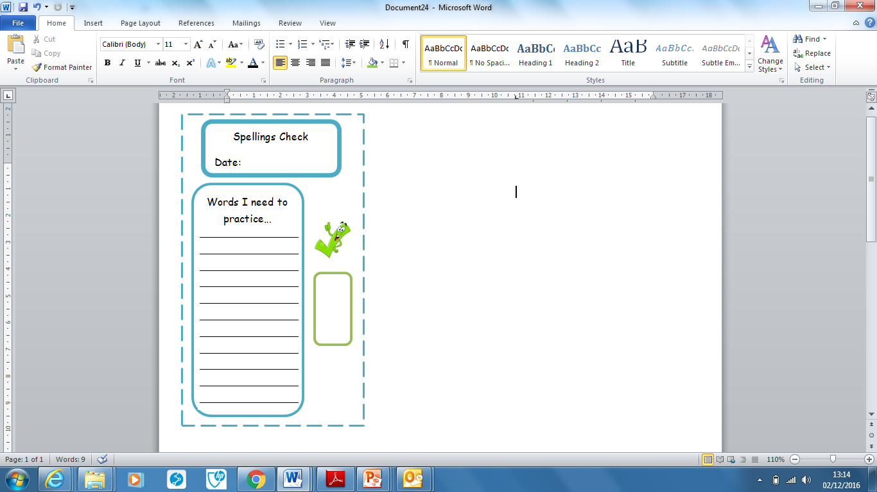
Spellings | Monday | Tuesday | Wednesday | Thursday | Friday
again
nowhere
resistance
friction
forces
method
looked
October
where
ancient

Ask for help if you are not sure what to do. Challenge on the back of this spelling sheet can you use each of your spellings in a sentence?

