This week’s sounds:
Prefixes –mis –un –dis -in
DUE: Friday 13th September
Week Beginning: 2nd September
MAKE SURE YOU KNOW WHAT EACH WORD MEANS - USE A DICTIONARY
 | Word List |  |  |  |  | 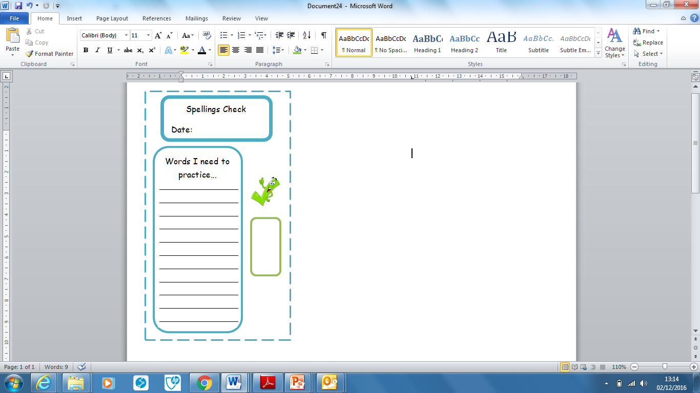
Spellings | Monday | Tuesday | Wednesday | Thursday | Friday
disagree
inactive
inhuman
misbehave
mislead
mismatch
misplace
mistreat
unfair
unkind
Ask for help if you are not sure what to do. Challenge on the back of this spelling sheet can you use each of your spellings in a sentence?

