Spellings letter string -ough
TEST: Monday 10th Feb 2025
Week 5 Spring 1
MAKE SURE YOU KNOW WHAT EACH WORD MEANS - USE A DICTIONARY
 | Word List |  |  |  |  | 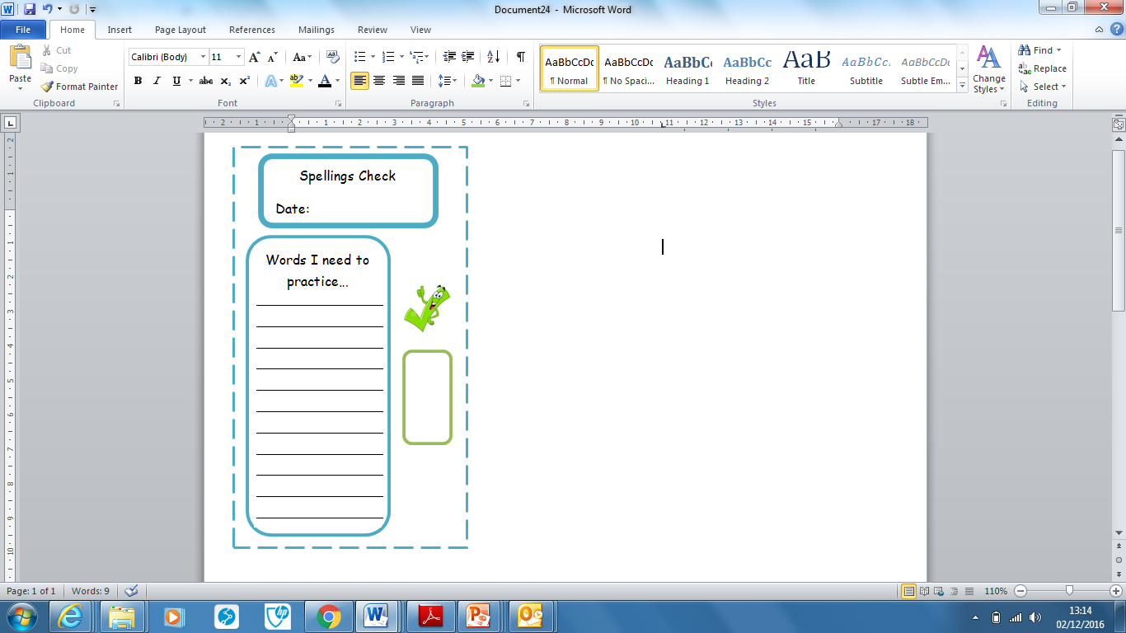
Spellings | Monday | Tuesday | Wednesday | Thursday | Friday
fought
nought
ought
bought
cough
trough
rough
tough
enough
thorough

Ask for help if you are not sure what to do. Challenge on the back of this spelling sheet can you use each of your spellings in a sentence?

