This week’s sounds:
Common exception words
DUE: Friday 11th October
Week Beginning: 30th September
MAKE SURE YOU KNOW WHAT EACH WORD MEANS - USE A DICTIONARY
 | Word List |  |  |  |  | 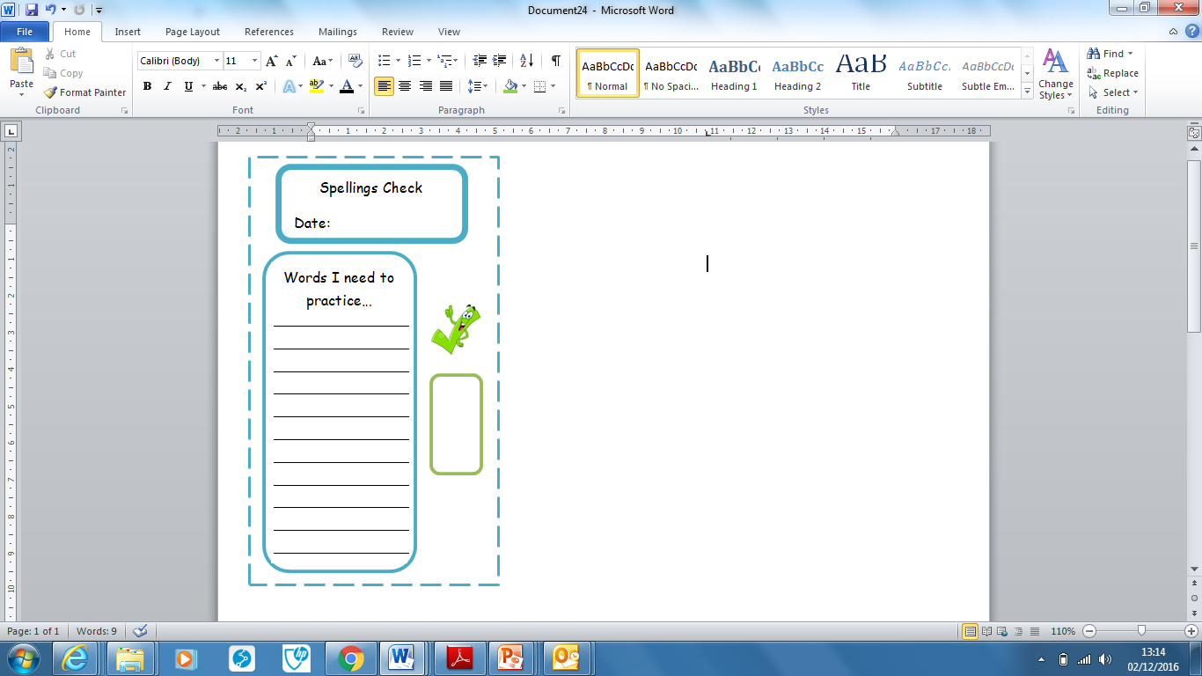
Spellings | Monday | Tuesday | Wednesday | Thursday | Friday
half
hold
kind
last
many
mind
Ask for help if you are not sure what to do. Challenge on the back of this spelling sheet can you use each of your spellings in a sentence?

