This week’s sounds:
Common exception words
DUE: Friday 27th October
Week Beginning: 14th October
MAKE SURE YOU KNOW WHAT EACH WORD MEANS - USE A DICTIONARY
 | Word List |  |  |  |  | 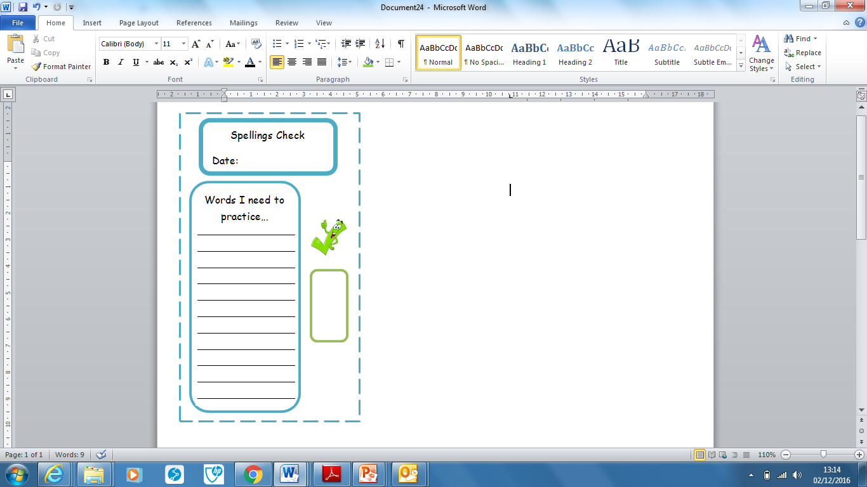
Spellings | Monday | Tuesday | Wednesday | Thursday | Friday
pass
past
path
people
plant
poor
Ask for help if you are not sure what to do. Challenge on the back of this spelling sheet can you use each of your spellings in a sentence?

