Spellings literacy words
TEST: Monday 17th March 2025
Week 2 Spring 3
MAKE SURE YOU KNOW WHAT EACH WORD MEANS - USE A DICTIONARY
 | Word List |  |  |  |  | 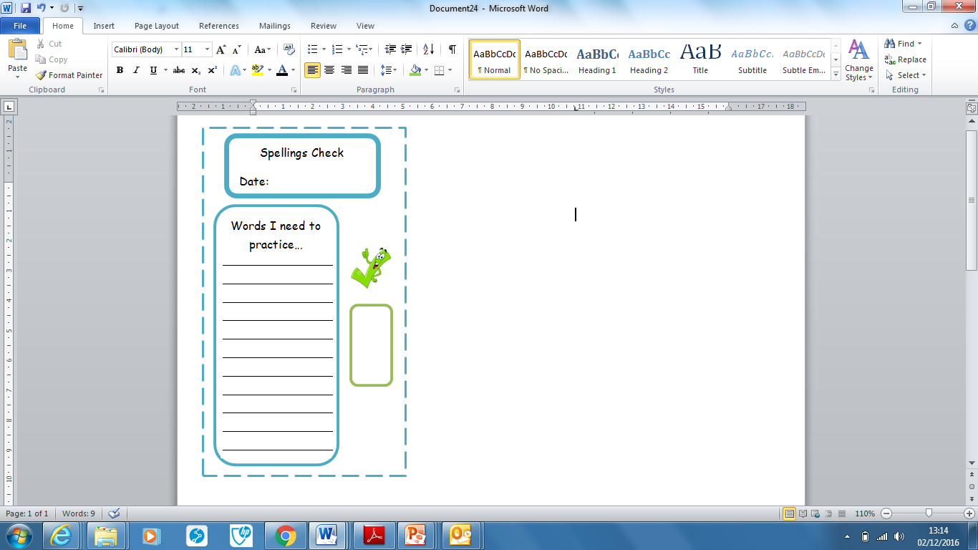
Spellings | Monday | Tuesday | Wednesday | Thursday | Friday
determined
essential
must-have
guaranteed
amazing
ideal
gadget
purchase
feature
additionally

Ask for help if you are not sure what to do. Challenge on the back of this spelling sheet can you use each of your spellings in a sentence?

