This week’s sounds:
Mix of common exception words and –zhuh words spelt -sure
DUE: Friday 13th September
Week Beginning: 9th September
MAKE SURE YOU KNOW WHAT EACH WORD MEANS - USE A DICTIONARY
 | Word List |  |  |  |  | 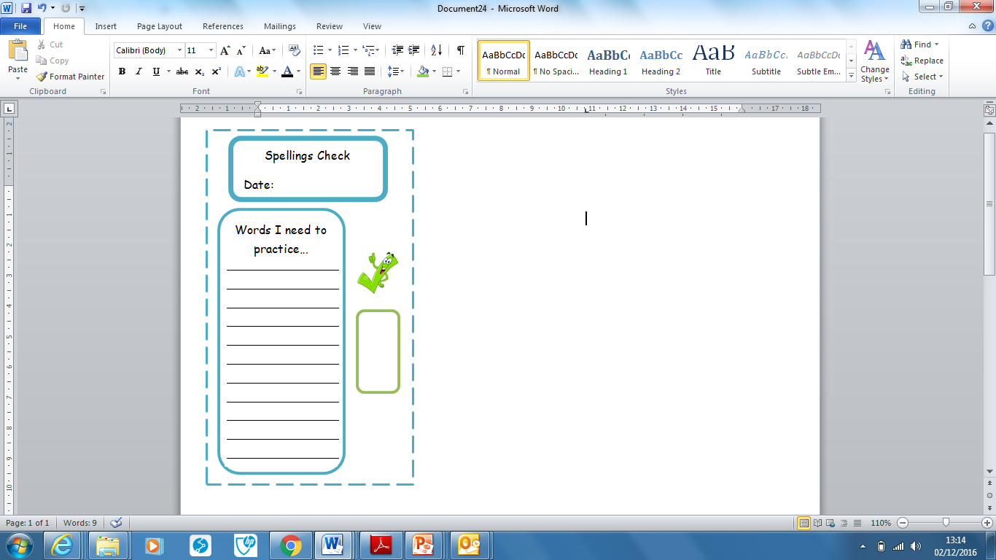
Spellings | Monday | Tuesday | Wednesday | Thursday | Friday
behind
both
break
busy
child
children
leisure
measure
treasure
pleasure
Ask for help if you are not sure what to do. Challenge on the back of this spelling sheet can you use each of your spellings in a sentence?

