Spellings unusual spellings
TEST: Monday 24th March 2025
Week 2 Spring 4
MAKE SURE YOU KNOW WHAT EACH WORD MEANS - USE A DICTIONARY
 | Word List |  |  |  |  | 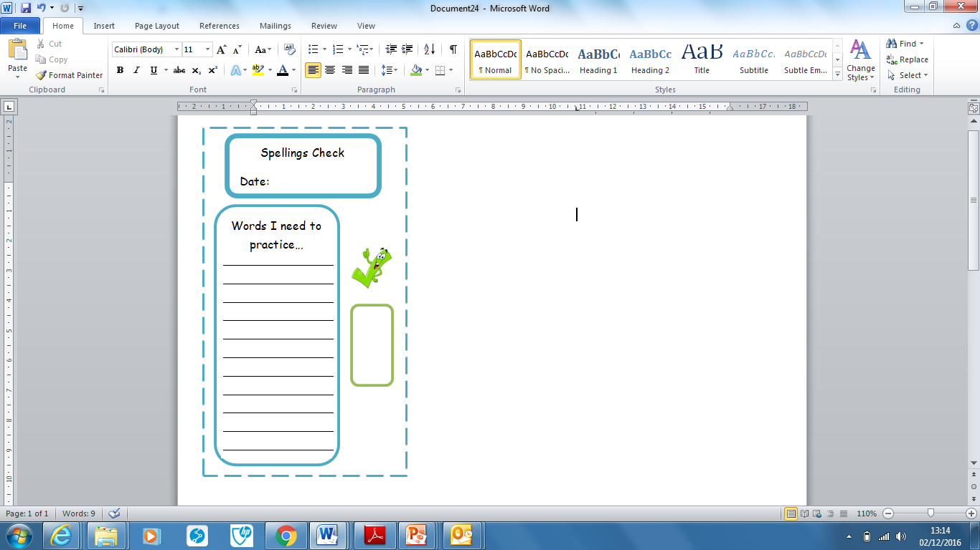
Spellings | Monday | Tuesday | Wednesday | Thursday | Friday
average
desperate
temperature
vegetable
frequently
equipment
symbol
forty
doubt
thumb

Ask for help if you are not sure what to do. Challenge on the back of this spelling sheet can you use each of your spellings in a sentence?

