Year 3: 10 Minute Challenges Autumn 1 Week 1 – Due Friday 11th September 2026

Our ‘Word of the Week’ is: courageous


Maths – TT Rock Stars

Spend 10 minutes on TT Rock Stars this week.
Can you get yourself onto the leader board?

Answer these questions:

Spellings (see separate sheet) You will be tested on a Friday.

Handwriting
Let’s learn our Year 3 words while practising our neatest handwriting. Trace the words and then write them on the lines.
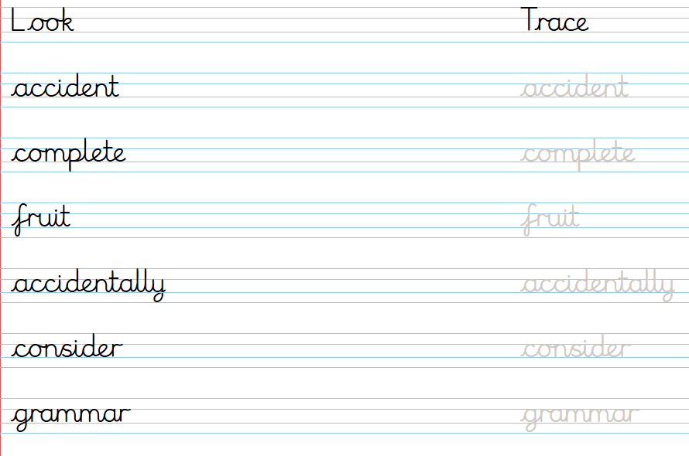

Reading
Try and read for 10 minutes each night. Remember to record it in your reading book.

Maths
Answer these questions to practise what we have been learning:


