This week’s words have ‘-es’ added to them and the suffix ‘-ing’.

DUE: Friday 11th September 2026
Week Beginning:
MAKE SURE YOU KNOW WHAT EACH WORD MEANS - USE A DICTIONARY
 | Word List |  |  |  |  | 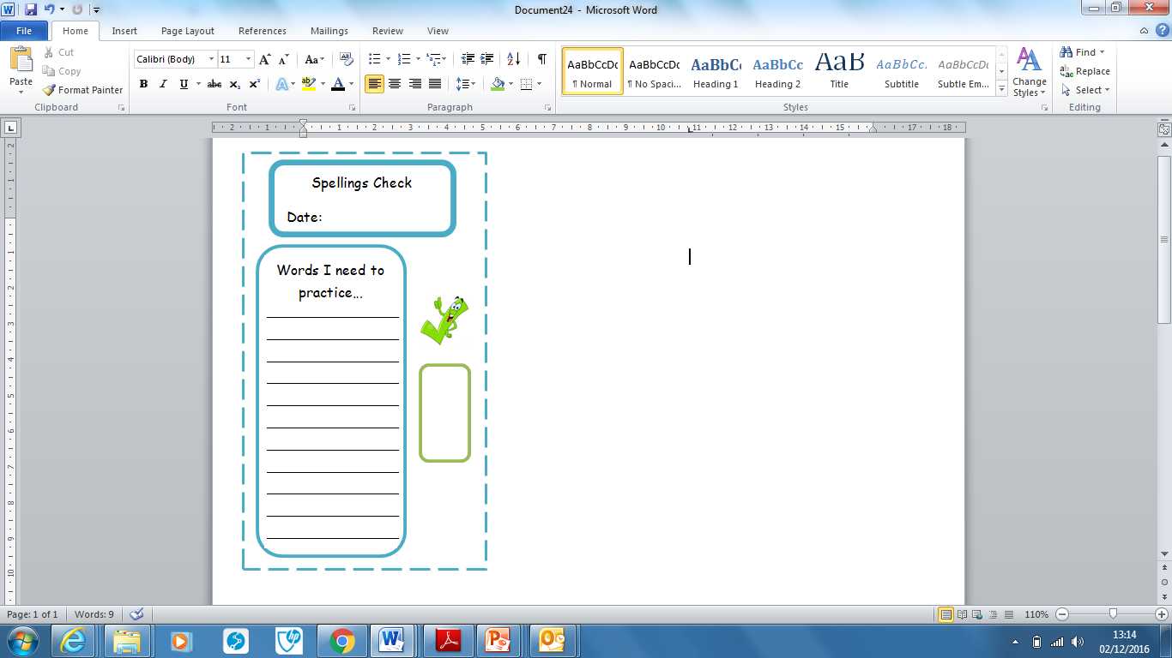
Spellings | Monday | Tuesday | Wednesday | Thursday | Friday
lorries
cities
babies
relies
replying
worrying
studying
applying
often
learn

Our Word Aware word of the week is ‘courageous.’ Can you remember what this means and how to use it in a sentence?

