Useful Vocabulary | Definition
classification | Putting animals into different groups based on similar characteristics e.g. mammals, birds, reptiles, amphibians and fish.
mammal | An animal with hair or fur on its body.
bird | An animal with feathers, wings and a beak.
fish | Animals that live in water and have fins and gills. Most fish have scales.
amphibians | An animal that lives on land and in water.
reptile | An animal with dry scales on its body.
carnivore | An animal that eats other animals.
herbivore | An animal that eats only plants.
omnivore | An animal that eats plants and other animals.
insectivore | An animal that feeds on insects.
Shelter | A plane that gives protection from the weather and danger.
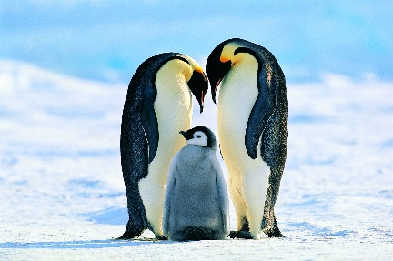
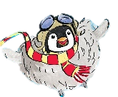
Did you know?
- Penguins don’t have any teeth.
- A penguin’s colouring allows it to be camouflaged in its habitat.
- Penguins can swim at speeds of up to 15 miles per hour.
- When a penguin slides on their tummy, it is called tobogganing.
- Penguin chicks recognise their parents by the unique noise they make.
- A group of penguins is called a colony, or a waddle when on land and a raft when at sea.
- Penguins’ feathers are waterproof.

Year 2 – Autumn 1 – Science
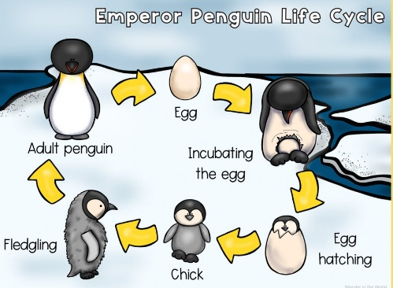
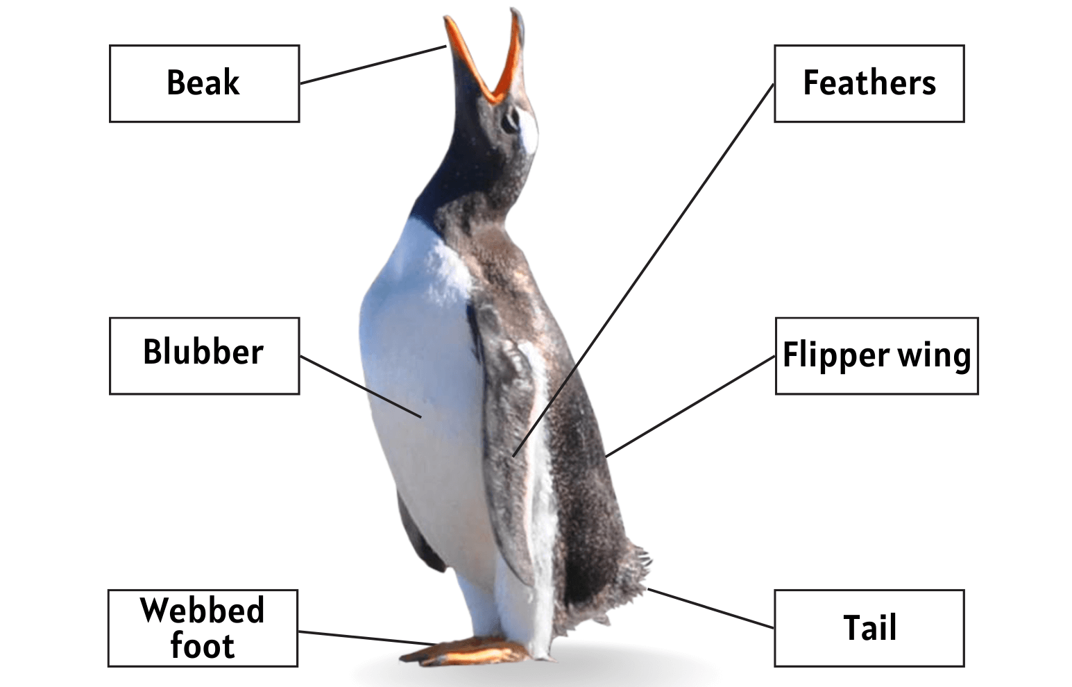
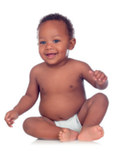
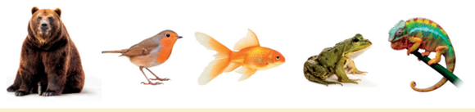

- What 5 things do all animals need for survival?
- How can I identify a bird/mammal/fish etc?
- Is a human a mammal? How do you know?
- Which animal group also needs heat for survival?
- What is the difference between a carnivore, herbivore, omnivore and insectivore?

