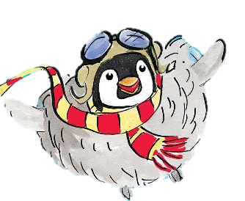
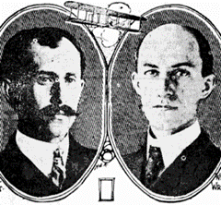
Year 2, Autumn 1 – History and D&T

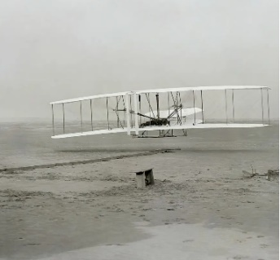
- Who were the wright brothers? What did they do?
- When was the first flight?
- Why are Bessie Coleman and Amelia Earhart significant?
- Why was the Moon landing special?
- What has changed about airplanes over time?



Useful Vocabulary | Definition
Past | Something that has already happened.
Present | Something that is happening now.
Inventor | Someone who makes something.
Living memory | An event that people alive today can remember and talk about.
Evidence | Information from books, pictures or people that tell us about the past.
Lever | Something that turns on a pivot to make work easier, such as a door handle or a seesaw.
Pivot | A central point from where something can turn, like your elbow or the middle of a seesaw
Mechanism | A collection of parts that work together to create a movement, such as the parts of a bicycle
Input | The action that starts the movement e.g. pedal a bike.
output | The movement e.g. wheels turn.
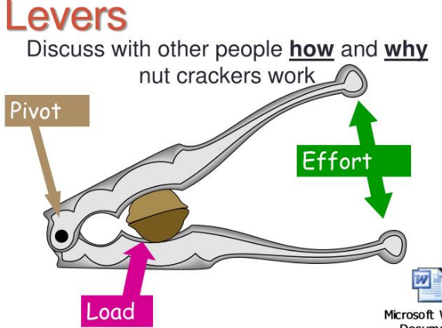
- What is a mechanism?
- Can you spot some mechanisms in everyday objects e.g. a door handle, seesaw, bike etc.
- What is a pivot?
- What is a lever?
- How can a mechanism help Geronimo to fly?


