Year 2, Autumn 1 – Religious Education and SCARF

In Religious Education this term, the children are thinking about the question “What is the good news that Christian’s believe Jesus brings?” The children will be learning about the story of Mathew the Debt Collector who was forgiven by Jesus and became a disciple. Disciples spread Jesus’s message of love, forgiveness and peace. The children will be learning about current world changers like Greta Thunberg and how they make our world a better place. We will explore themes of forgiveness within these lessons, which will help children relate their own lives to the way Christians live.

Useful Vocabulary | Definition
Christians | people who follow Christianity and believe Jesus is the Saviour who healed the rift between humanity and God
Jesus | a very important person for Christians; God in the flesh
Mathew | a tax collector who Jesus called to follow him and who left his job as a tax collector.
Fishermen | people who earn a living through fishing
Disciples | a follower of Jesus
Tax collector | a person who collects money on behalf of the Romans at the time of Jesus
Peace | freedom from conflict
Forgiveness | when someone is stopped being blamed or punished for something they have done
Apostles | the twelve followers of Jesus who went with him during his earthly ministry
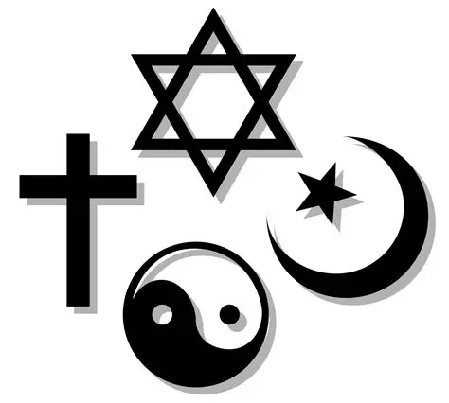

In PSHE this half term, the children are learning about how to make the ideal classroom and learning our school rules. We will also look at feelings and how different situations can make us feel and what we can do to overcome those emotions. We are going to talk about what makes a good friend, the differences between teasing and bullying and who to talk to if they feel they are being bullied.


