Key Vocabulary | Definition
group | 3 groups of 10 is 30.
altogether | 20 + 6 = 26, altogether we have 26.
strategy | Different ways of getting the right answer.
left over | I have 4 groups of ten and 3 left over, my number is 43.
digit | A number.
1 digit number | One number by itself e.g. 1, 4, 7, 6, 3 etc.
2-didgit number | A number with two digit such as 45, 68, 33, 12.
value | The value of the 2 in 27 is 20.
worth | The 4 in 42 is worth 40 or 4 tens.
partition | Splitting a whole number into parts.
represent | To show something e.g. represent 34 on a bead string.
compare | What are the differences and similarities.
decreasing | A number is getting smaller.
increasing | A number is getting bigger.
derive | What do we know?
fewer | There are fewer purple flowers than orange flowers.
less | There are 5 less.
bar Model | Another way to show the whole numbers and its parts.
known | What numbers do we know?
unknown | What numbers don’t we know?
Year 2, Autumn 1 – knowledge Organiser – Maths

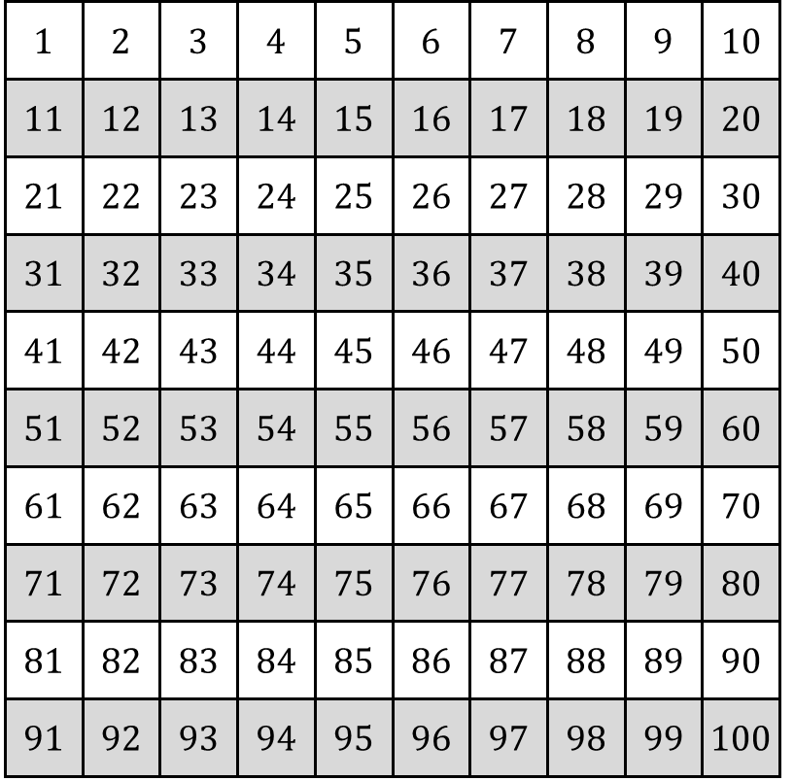
If I know that 2 + 3 = 5 | Then I know that 12 + 3 = 15
If I know that 5 – 2 = 3 | Then I know that 15 – 3 = 13
If I know that 2 + 3 + 4 = 9 | Then I know that 20 + 30 + 40 = 90
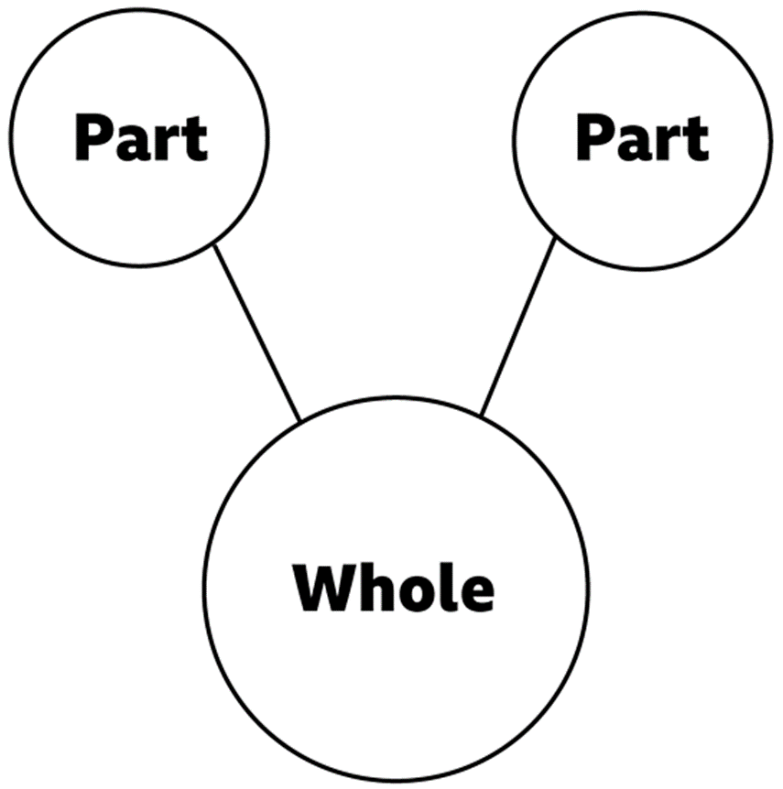
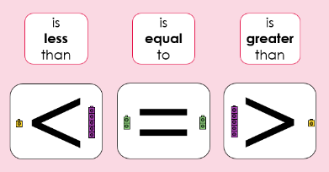
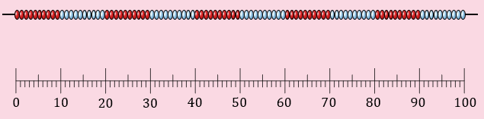
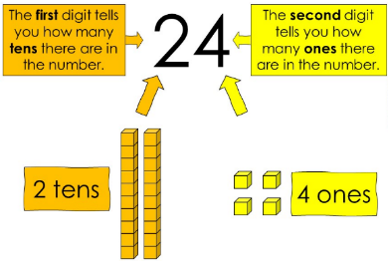
Unit 1: Numbers within 100
Year 2, Autumn 1 – Knowledge Organiser – Maths
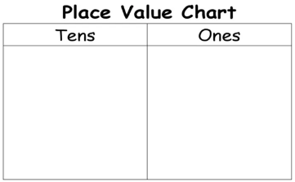

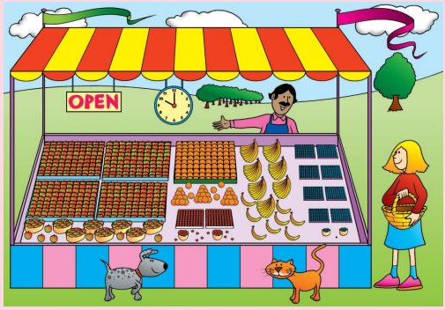
Unit 2: Addition and subtraction of 2-digit numbers

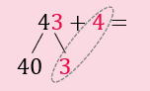

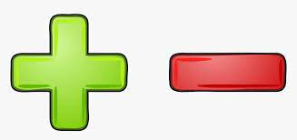
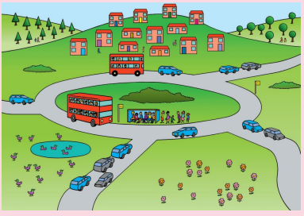
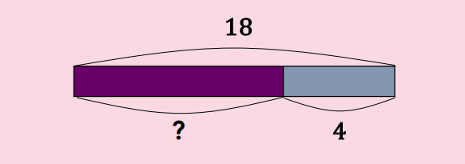
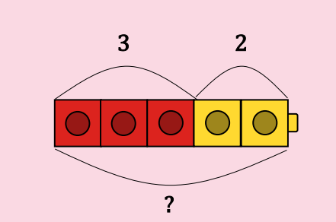
Unit 3: Addition and Subtraction word problems

