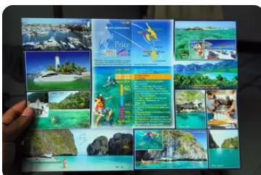
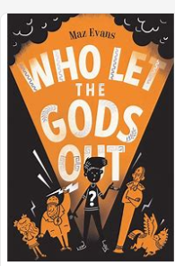
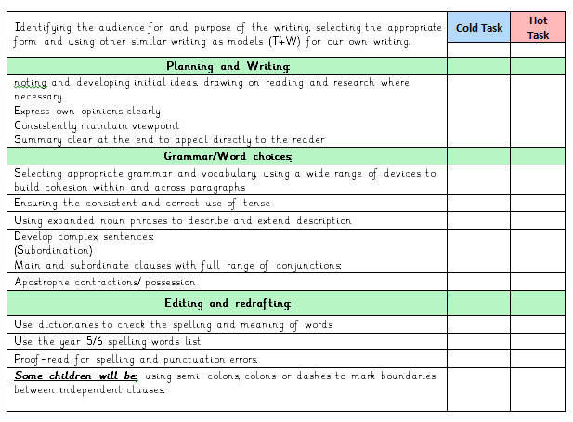
We will also be creating a holiday brochure.
This half term in our Talk for Writing unit we will be creating a portal story inspired by our whole class story ‘Who Let the Gods Out?’!

SPAG: Speech, Parenthesis, Capital letters will also be a focus

